**Appendix**

**Heatmap**

**Visualization for numerical features**

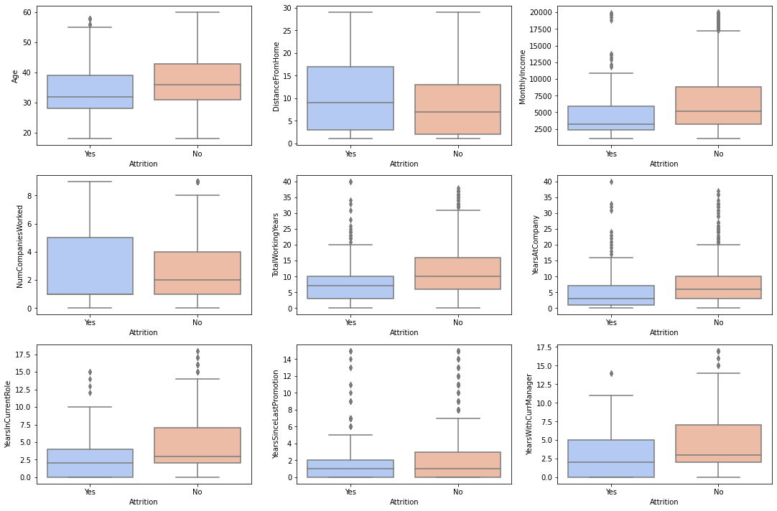

**Job Satisfaction and attrition**

